HM1 Implementation

Class Server
Java implementation that purposefully handles multiple socket connections on port 8080. This is a simple server that Takes in a client number and a message and responds with the timestamp, client number, and message.
The ClientHandler extends the Thread class which means each socket will have a dedicated kernel thread achieving proper multiprocessing handing multiple sockets at once.
This ClientHandler achieves RAII by overloading the run() with proper releasing of resources back to the host machine.

Class Client
Java implementation that purposefully connects to a local server at port 8080. The Client Class has a function void sendClientNumber(clientNumber, hostname, port, message) that requests a socket connection to the server and reading only 1 line from the server.

Error Handling and Tests
Maven was installed with Mocktio to create test cases that made sure that common exceptions were being thrown for both client and server.
Test 1: testClientProcessCommunication()
Provides the ideal function of the Server and Client
Test 2: testSocketIOException()
Provides the function that mocks when the server is down and the client is trying to send a message ultimately receiving with an I/O Exception.
Test 3: testClientHandlerIOException()
Provides the function that mocks when the server sends the client a message that the client cannot receive with an I/O Exception.
Test 4: testClientHandlerGenericException()
Provides the scenario where the Server evokes a runtime error
Test 5: testClientHandlerCloseIOException()
This scenario provides an I/O Exception on socket close after a request has been completed.
Test 6: testClientHandlerCloseGenericException()
This scenario provides a runtime error on the server after the request has been completed.
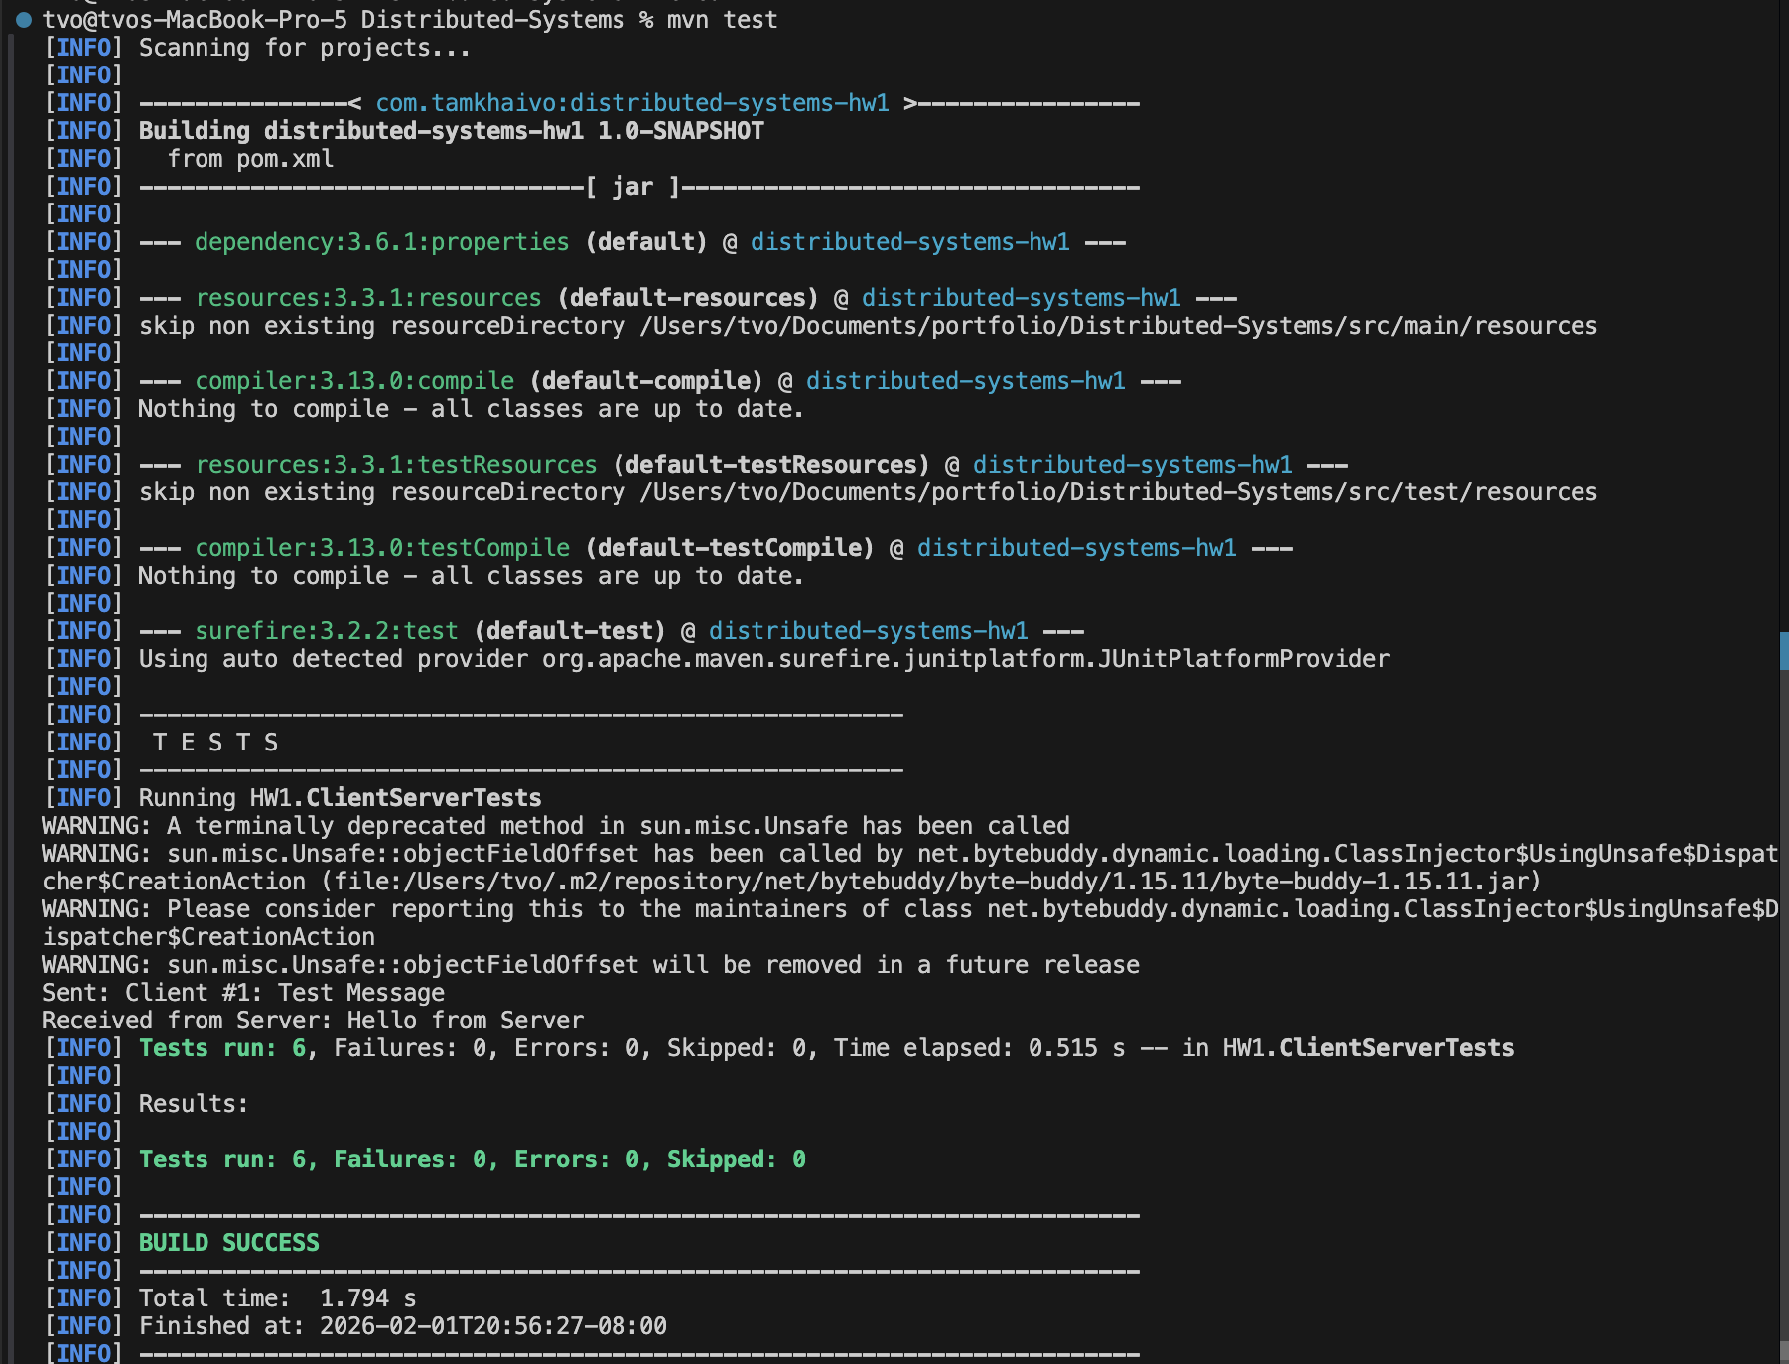

Observations
I observed that manually working with sockets and IP addresses were cumbersome. I’d expect the server socket and IP address to be automatically assigned and return the necessary information via an interface. The client will receive this through a domain name service.

Challenges
The main challenge was to create the test that encapsulates all the common errors. I had to refresh my knowledge with testing frameworks such as Mockito and Junit. Mockito was better in testing these errors. I like how I can mock an error on a specific function.

